Exercise 1 – ReactJS-HOL

App.js

import React from 'react'; function App() {
return (
<div>
<h1>Welcome to the first session of React</h1>
</div>
);
}
export default App;

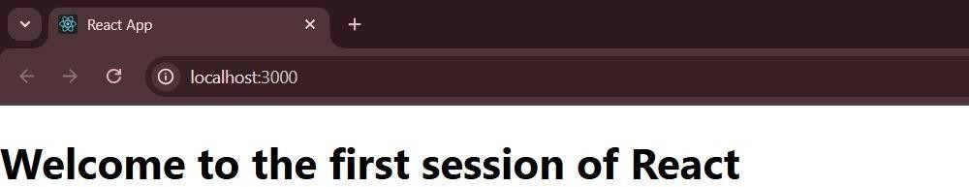
Output:

Exercise 2 – ReactJS-HOL

Home.js
import React from 'react'; function Home() {

return (
<div>
<h2>Welcome to the Home page of Student Management Portal</h2>
</div>
);
}
export default Home;

About.js
import React from 'react'; function About() { return (
<div>
<h2>Welcome to the About page of the Student Management Portal</h2>
</div>
);
}
export default About;

Contact.js
import React from 'react'; function Contact() { return (
<div>
<h2>Welcome to the Contact page of the Student Management Portal</h2>
</div>
);

}
export default Contact;

App.js
import React from 'react'; import './App.css';
import Home from './Components/Home'; import About from './About';
import Contact from './Contact'; function App() {
return (
<div className="App">
<Home />
<About />
<Contact />
</div>
);
}
export default App;

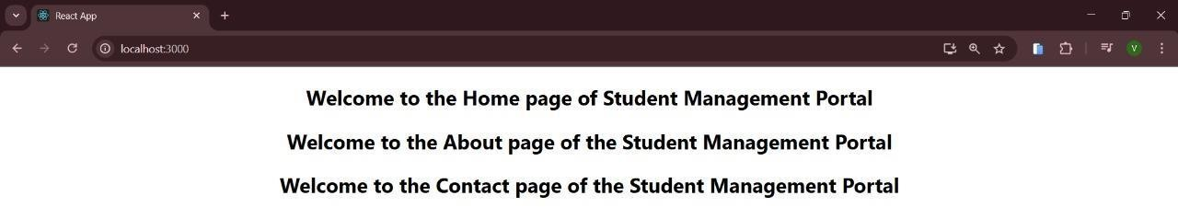
Output:

Exercise 3 – ReactJS-HOL

CalculateScore.js
import React from 'react';
import '../Stylesheets/mystyle.css'; function CalculateScore() {
const name = "John Doe";
const school = "Greenwood High"; const total = 450;
const goal = 500;
const average = (total / goal) * 100; return (
<div className="score-card">
<h2>Student Score Details</h2>
<p><strong>Name:</strong> {name}</p>
<p><strong>School:</strong> {school}</p>
<p><strong>Total Score:</strong> {total}</p>
<p><strong>Goal Score:</strong> {goal}</p>
<p><strong>Average:</strong> {average.toFixed(2)}%</p>
</div>
);
}
export default CalculateScore;

mystyle.css
.score-card {
background-color: #f2f2f2;

border: 2px solid #ccc; padding: 20px; margin: 30px auto; width: 400px;
border-radius: 10px; text-align: left;
font-family: Arial, sans-serif;
box-shadow: 2px 2px 10px rgba(0,0,0,0.1);
}
.score-card h2 { color: #333;
text-align: center;
}
.score-card p { margin: 10px 0;
color: #444;
}

App.js
import React from 'react'; import './App.css';
import CalculateScore from './Components/CalculateScore'; function App() {
return (
<div className="App">
<CalculateScore />
</div>

);
}

export default App;

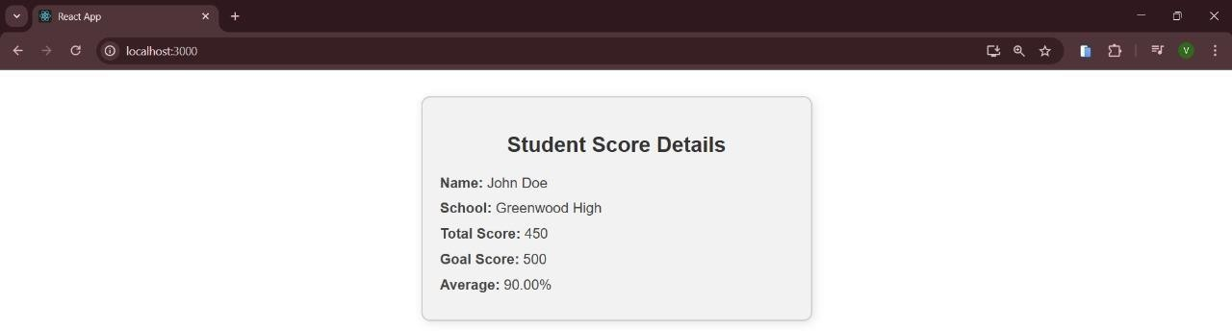
Output:

Exercise 4 – ReactJS-HOL

Post.js
import React from 'react'; function Post(props) { return (
<div style={{border: "1px solid #ddd", padding: "15px", margin: "10px 0"}}>
<h3>{props.title}</h3>
<p>{props.body}</p>
</div>
);
}

export default Post;

Posts.js
import React, { Component } from 'react'; import Post from './Post';
class Posts extends Component { constructor(props) { super(props);
this.state = { posts: [], hasError: false
};
}
loadPosts() { fetch('https://jsonplaceholder.typicode.com/posts')
.then(res => res.json())
.then(data => {
this.setState({ posts: data.slice(0, 10) }); // load only first 10 posts
})
.catch(error => { console.error('Fetch error:', error); this.setState({ hasError: true });
});
}
componentDidMount() { this.loadPosts(); } componentDidCatch(error, info) {

alert("An error occurred while rendering Posts component."); console.error("Error caught:", error, info);
this.setState({ hasError: true });
}
render() {
if (this.state.hasError) {
return <h2>Something went wrong while loading posts.</h2>;
}
return (
<div style={{padding: '20px'}}>
<h1>Blog Posts</h1>
{this.state.posts.map(post => (
<Post key={post.id} title={post.title} body={post.body} />
))}
</div>
);
}}
export default Posts;

App.js
import React from 'react'; import './App.css';
import Posts from './Posts'; function App() {
return (
<div className="App">
<Posts />

</div>
);
}
export default App;


Output:

Exercise 5 – ReactJS-HOL

CohortDetails.module.css
.box {
width: 300px; display: inline-block; margin: 10px; padding: 20px;
border: 1px solid black;

border-radius: 10px; vertical-align: top;
font-family: Arial, sans-serif;
box-shadow: 2px 2px 8px rgba(0, 0, 0, 0.05); text-align: left;
}
dt {
font-weight: 500; margin-top: 10px;
}
dd {
margin: 0 0 10px 0;
}

CohortDetails.js
import React from 'react';
import styles from './CohortDetails.module.css';
function CohortDetails({ cohortName, startDate, endDate, status }) { const headingStyle = {
color: status === 'ongoing' ? 'green' : 'blue'
};
return (
<div className={styles.box}>
<h3 style={headingStyle}>{cohortName}</h3>
<dl>
<dt>Start Date:</dt>
<dd>{startDate}</dd>

<dt>End Date:</dt>
<dd>{endDate}</dd>
<dt>Status:</dt>
<dd>{status}</dd>
</dl>
</div>
);
}
export default CohortDetails;

App.js
import React from 'react'; import './App.css';
import CohortDetails from './CohortDetails'; function App() {
return (
<div className="App">
<h1>My Academy Cohorts</h1>
<CohortDetails cohortName="React Bootcamp" startDate="2025-06-01" endDate="2025-07-15" status="ongoing"
/>
<CohortDetails cohortName="Java Spring Batch" startDate="2025-05-01"

endDate="2025-06-10" status="completed"
/>
</div>
); }
export default App;

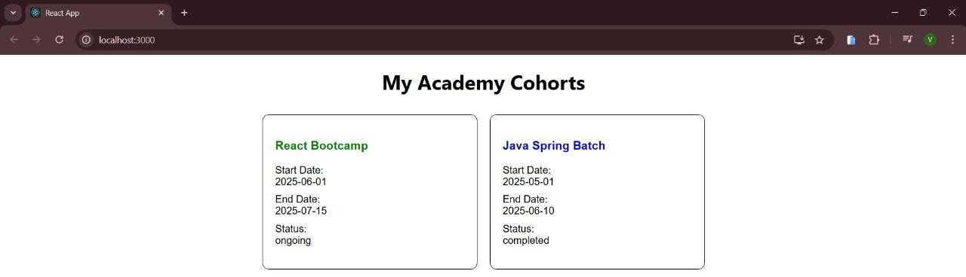
Output:

